ZERO TRUST ARCHITECTURE FOR ENTERPRISE SECURITY

Submitted By
Divya Gunvant Khodankar

Internship Domain
Cyber Security

Submitted To
Naviotech Solution Pvt. Ltd.
College Name
P.R.Pote Patil College Of Engineering And Management, Amaravati
Date of Submission
15.05.2026

ABSTRACT

Traditional network security models assume that everything inside the corporate network can be trusted. However, modern cyber threats such as insider attacks, phishing, ransomware, and credential theft have made perimeter-based security ineffective.
Zero Trust Architecture (ZTA) is a modern cybersecurity model based on the principle “Never Trust, Always Verify.” This project explores the implementation of Zero Trust Architecture in enterprise environments using authentication mechanisms such as Multi-Factor Authentication (MFA), Role-Based Access Control (RBAC), encryption, and continuous monitoring.
The project also demonstrates virtualization concepts using VMware Workstation and simulates enterprise access control using cloud-based permission systems. Threat simulations were performed to evaluate the effectiveness of the Zero Trust framework against unauthorized access attempts.
The implementation demonstrates how organizations can reduce cybersecurity risks by continuously verifying users, restricting access permissions, and monitoring enterprise resources.
Keywords: Zero Trust, MFA, RBAC, IAM, Cybersecurity, Enterprise Security, Access Control, Virtualization

TABLE OF CONTENTS

Sr. No. | Contents | Page No.
 | Abstract
1. | Introduction | 4
2. | Objectives | 5
3. | Zero Trust Principles | 6
4. | Authentication Models | 9
5. | Zero Trust Framework Design | 12
6. | Virtualization Environment | 14
7. | Access Control Implementation | 16
8. | Threat Simulation and Testing | 17
9. | Results and Analysis | 19
10. | Best Practices for Zero Trust Security | 20
11. | Conclusion | 21
12. | References | 21

LIST OF TABLES

Table No. | Table Name | Page No.
Table 1 | Core Principles of Zero Trust Architecture | 7
Table 2 | Authentication Factors in MFA | 9
Table 3 | RBAC Roles and Permissions | 10
Table 4 | Virtualization Tools and Purpose | 14
Table 5 | Security Testing Results | 18

LIST OF FIGURES

Figure No. | Figure Name | Page No.
Figure 1 | Multi-Factor Authentication Configuration | 10
Figure 2 | Role-Based Access Control Permission Configuration | 11
Figure 3 | Zero Trust Architecture Framework | 13
Figure 4 | VMware Virtualization Environment | 15
Figure 5 | Insider Threat Simulation | 18

- INTRODUCTION
Enterprise organizations are increasingly targeted by sophisticated cyberattacks due to digital transformation, cloud computing, remote work environments, and internet-connected devices. Traditional security models rely on perimeter-based protection where users inside the network are trusted automatically. However, modern attacks exploit insider threats, stolen credentials, and compromised devices.
Zero Trust Architecture (ZTA) is a modern cybersecurity framework designed to eliminate implicit trust. Every user, device, and application must continuously verify identity and authorization before accessing organizational resources.
The core philosophy of Zero Trust is:

“Never Trust, Always Verify.”
This project demonstrates the implementation of Zero Trust concepts using:
- Multi-Factor Authentication (MFA)
- Role-Based Access Control (RBAC)
- Identity verification
- Continuous monitoring
- Virtualization concepts
- Threat simulations
The project focuses on improving enterprise security by minimizing unauthorized access and strengthening identity verification mechanisms.

2. OBJECTIVES
The objectives of this project are:
- To understand the principles of Zero Trust Architecture.
- To study authentication models such as MFA and RBAC.
- To design a Zero Trust security framework.
- To explore virtualization concepts using VMware Workstation.
- To implement access control policies using RBAC.
- To simulate insider threat scenarios.
- To analyze the effectiveness of Zero Trust security mechanisms.
- To document findings and suggest cybersecurity improvements.

3. ZERO TRUST PRINCIPLES
Zero Trust Architecture is based on several core cybersecurity principles that strengthen enterprise security.

3.1 Never Trust, Always Verify
Every user and device must be continuously authenticated and verified before access is granted.

3.2 Least Privilege Access
Users should only receive minimum permissions necessary to perform their tasks.

3.3 Continuous Monitoring
Enterprise systems should continuously monitor user activity and network behavior.

3.4 Identity Verification
User identity must be validated through secure authentication methods.

3.5 Assume Breach
Organizations should assume attackers may already exist inside the network and implement defensive controls accordingly.

Table 1: Core Principles of Zero Trust Architecture
Principle | Description
Never Trust | Verify all users continuously
Least Privilege | Minimum access permissions
Continuous Monitoring | Monitor user activities
MFA | Multiple authentication layers
RBAC | Role-based authorization

4. AUTHENTICATION MODELS

4.1 Multi-Factor Authentication (MFA)
Multi-Factor Authentication improves login security by requiring multiple verification methods before granting access.

Authentication Factors:

Table 2: Authentication Factors in MFA
Factor Type | Example
Something You Know | Password
Something You Have | OTP Token
Something You Are | Fingerprint

Advantages of MFA
- Prevents unauthorized access
- Improves login security
- Reduces credential theft risks
- Protects enterprise resources
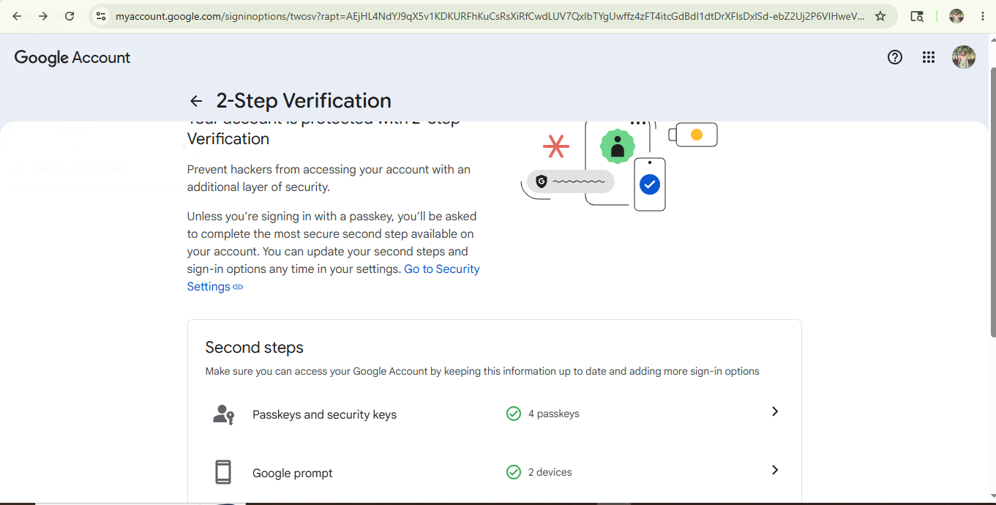

Figure 1: Multi-Factor Authentication Configuration

4.2 Role-Based Access Control (RBAC)
Role-Based Access Control restricts system access according to user roles and responsibilities.
RBAC was demonstrated using cloud-based file sharing permissions where different users were assigned Viewer, Commenter, and Editor roles.

Table 3: RBAC Roles and Permissions
Role | Access Permission
Owner | Full control
Viewer | Read-only access
Commenter | Can comment
Editor | Full editing access

Benefits of RBAC
- Restricts unauthorized access
- Simplifies permission management
- Reduces insider threats
- Supports least privilege principle



Figure 2: Role-Based Access Control Permission Configuration

5. ZERO TRUST FRAMEWORK DESIGN
The proposed Zero Trust framework follows a continuous verification approach for enterprise security.

Proposed Workflow
User Request
↓
Identity Verification
↓
MFA Authentication
↓
RBAC Authorization
↓
Continuous Monitoring
↓
Access Granted / Denied

Framework Components
- Identity Verification
All users must verify identity before access.
- MFA Authentication
Additional authentication layers improve security.
- RBAC Authorization
Permissions are assigned based on organizational roles.
- Continuous Monitoring
User activity and network traffic are monitored continuously.
- Encryption
Sensitive enterprise data is protected using encryption techniques.
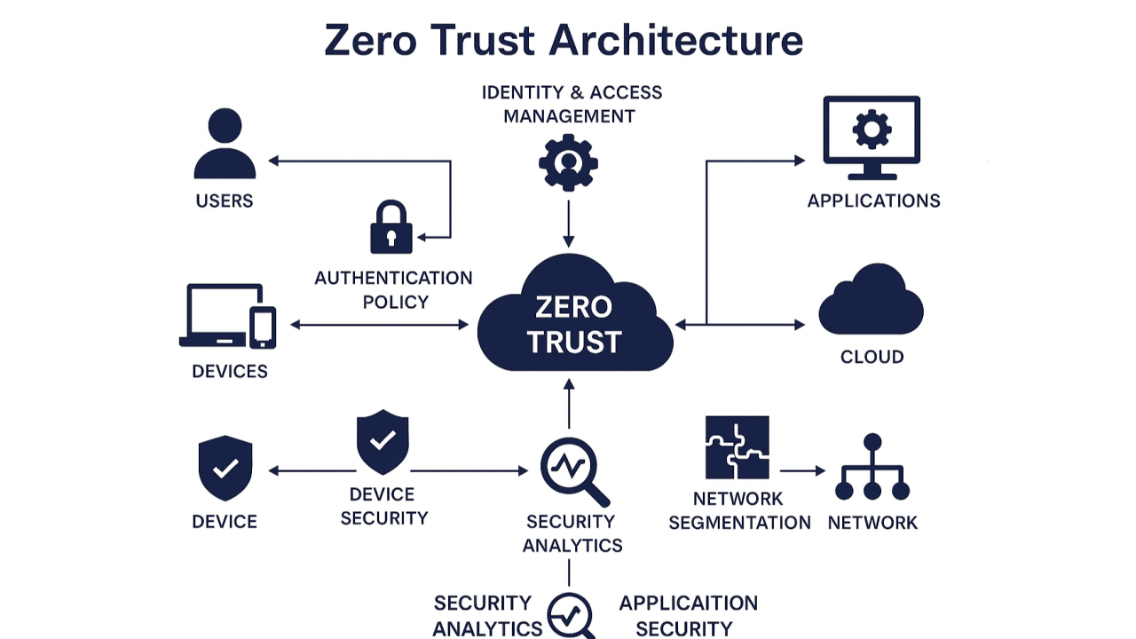

Figure 3: Zero Trust Architecture Framework

The above diagram illustrates the implementation workflow of Zero Trust Architecture including identity verification, MFA authentication, RBAC authorization, continuous monitoring, and network segmentation.

6. VIRTUALIZATION ENVIRONMENT
Virtualization technologies help organizations simulate enterprise environments for testing security controls and access management systems.
VMware Workstation was explored to understand virtualization concepts and enterprise security simulation.

Table 4: Virtualization Tools and Purpose
Tool | Purpose
VMware Workstation | Virtualization concepts
Google Drive | RBAC demonstration
Google Security Settings | MFA demonstration
Notepad | Threat simulation

Benefits of Virtualization
- Isolates enterprise systems
- Enables safe testing environments
- Supports cybersecurity simulations
- Helps evaluate security controls

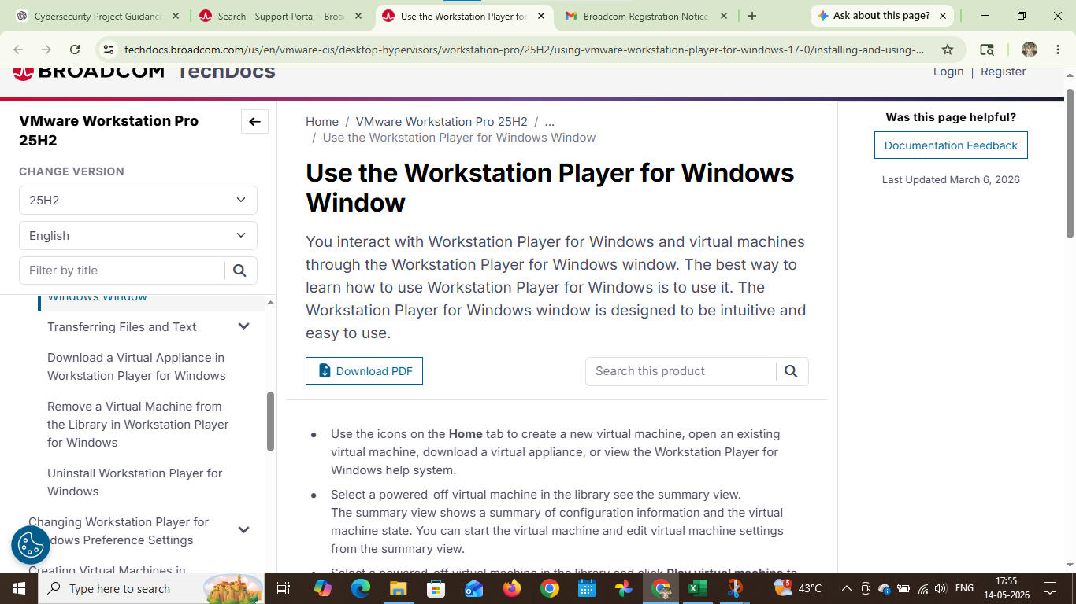

Figure 4: VMware Virtualization Environment
VMware Workstation was explored to understand virtualization concepts and enterprise environment simulation for Zero Trust implementation.

7. ACCESS CONTROL IMPLEMENTATION
Access control policies were implemented using cloud-based file sharing permissions to simulate enterprise access management.
Different access levels such as Owner, Viewer, Commenter, and Editor were assigned to demonstrate controlled access management.

Implemented Security Policies
Policy | Description
MFA Required | Identity verification required
Least Privilege | Minimum access permissions
Access Monitoring | User activities monitored
Role Restrictions | Access based on roles
RBAC helps organizations prevent unauthorized access and ensures users can only access resources relevant to their assigned responsibilities.

8. THREAT SIMULATION AND TESTING
Basic threat simulation scenarios were performed to evaluate the effectiveness of Zero Trust security controls.

8.1 Insider Threat Simulation

A simulated unauthorized access attempt was created using a controlled environment.

Scenario:

An unauthorized employee attempted to access confidential enterprise resources.

Result:

RBAC policies restricted unauthorized access successfully.

8.2 Credential Security Testing
MFA security settings were evaluated to demonstrate enhanced login security.

Result:

Additional verification methods improved authentication security.

Table 5: Security Testing Results
Attack Type | Security Control | Result
Unauthorized Access | RBAC | Blocked
Credential Theft | MFA | Prevented
Insider Threat | Continuous Monitoring | Detected

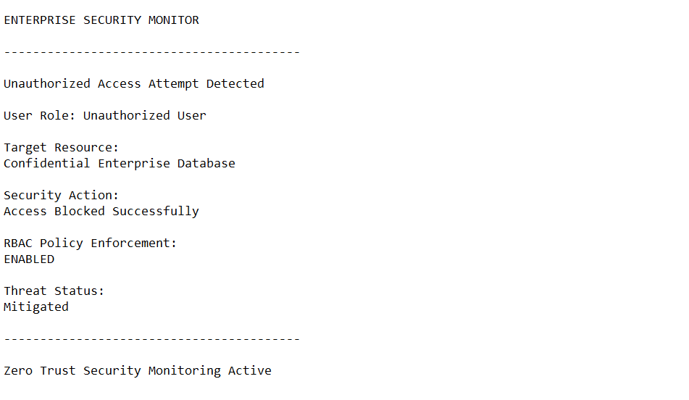

Figure 5: Insider Threat Simulation

The threat simulation demonstrates how unauthorized access attempts can be restricted using Role-Based Access Control (RBAC) and Zero Trust security policies within enterprise environments.

9. RESULTS AND ANALYSIS
The implementation of Zero Trust security principles improved enterprise security significantly.

Observations
- Unauthorized access attempts were restricted.
- MFA improved account security.
- RBAC reduced unnecessary access permissions.
- Continuous monitoring improved visibility of suspicious activities.
- Virtualization concepts helped understand enterprise security simulation.

Performance Analysis
Security Feature | Effectiveness
MFA | High
RBAC | High
Monitoring | High
Access Restriction | High
The project demonstrates that Zero Trust Architecture is effective for securing enterprise environments against modern cybersecurity threats.

10. BEST PRACTICES FOR ZERO TRUST SECURITY
- Enable Multi-Factor Authentication (MFA)
- Apply least privilege access policies
- Continuously monitor enterprise systems
- Encrypt sensitive organizational data
- Restrict unauthorized devices
- Regularly update security policies
- Conduct cybersecurity awareness training
- Monitor user activities continuously

11. CONCLUSION
This project successfully explored the implementation of Zero Trust Architecture for enterprise security.
The framework integrated authentication mechanisms such as MFA, RBAC, identity verification, and continuous monitoring to strengthen enterprise protection against cyber threats.
Practical demonstrations using RBAC permissions, MFA configurations, virtualization concepts, and threat simulations highlighted the importance of Zero Trust principles in modern cybersecurity.
The project concludes that Zero Trust Architecture is an effective cybersecurity model for reducing unauthorized access, improving enterprise security, and protecting sensitive organizational resources.

12. REFERENCES
- NIST Special Publication 800-207 – Zero Trust Architecture
- Microsoft Zero Trust Documentation
- VMware Workstation Documentation
- Google Security Documentation
- OWASP Security Guidelines
- Cisco Zero Trust Security Model
- IBM Cybersecurity Reports
- Palo Alto Networks Zero Trust Research
- Broadcom VMware Documentation
- National Institute of Standards and Technology (NIST)

